- We have cut our forecast for UK CPI inflation over the next couple of years. This largely reflects the financial market fallout from recent US tariff announcements, with the dollar having weakened and key commodity prices falling back. We expect the bulk of these shifts to stick in the near-term, leading us to lower our projections for imported goods, petrol, and energy prices.
- March's fall in inflation was as expected, with the services and fuel categories the main drivers. We expect inflation to rise sharply from April, due to regulated price increases and firms passing on some of the rise in labour costs, then continue to edge up. But a decline in the contribution from the energy category should see headline inflation start to soften from the autumn.
CPI inflation fell to 2.6% in March, from 2.8% in February, which was in line with our forecast. March's lower headline rate partly reflected strong base effects from the services category. Meanwhile, the fuel category also weighed on headline inflation in March, following a 1.1% m/m drop in petrol prices between March and February, compared to a 1.8% rise over the same period last year. This downward pressure was mitigated by the unwinding of February's temporary weakness in the volatile clothing sub-category. RPI and RPIX inflation also fell by 0.2ppts to 3.2% and 2.8% respectively.
Despite falling in two consecutive releases, inflation will almost certainly rebound sharply from April. This is due to large regulated price increases coming into play, while we also expect firms will pass on some of the rise in labour costs caused by recent increases in employers' national insurance contributions and the national living wage. We expect inflation to remain elevated throughout much of this year before cooling from the autumn, as the positive contribution from the energy category starts to fall back again.
The financial market response to recent US tariff announcements suggests inflation is likely to be slightly softer over the next couple of years than we previously expected. The dollar has weakened against sterling, which should weigh on the prices of imported goods. Meanwhile, oil and to a lesser extent European gas futures prices, have fallen. We expect the bulk of these shifts to hold in the near-term, leading us to nudge down our CPI inflation forecast to 3% in 2025 and 2.4% in 2026, from 3.1% and 2.7% last month.
Chart 1: A weaker dollar and lower commodity prices have pulled down our near-term inflation forecast
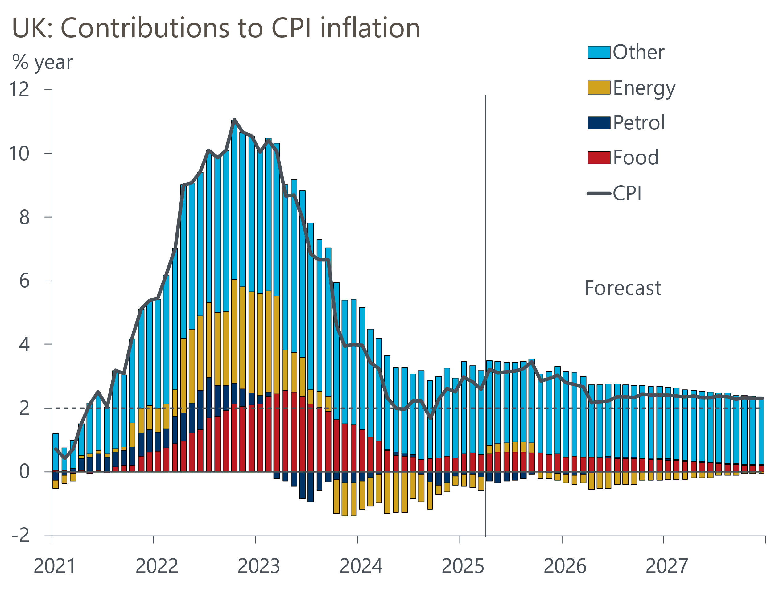
Source: Oxford Economics, Haver Analytics

